**CRA Taxes**

1. Select the Pay Business Tax menu. The option to pay CRA (Federal) and Provincial taxes is displayed. Click on **Your CRA Taxes** to process a CRA tax payment. Where the tax payee has previously been added, proceed to step 7

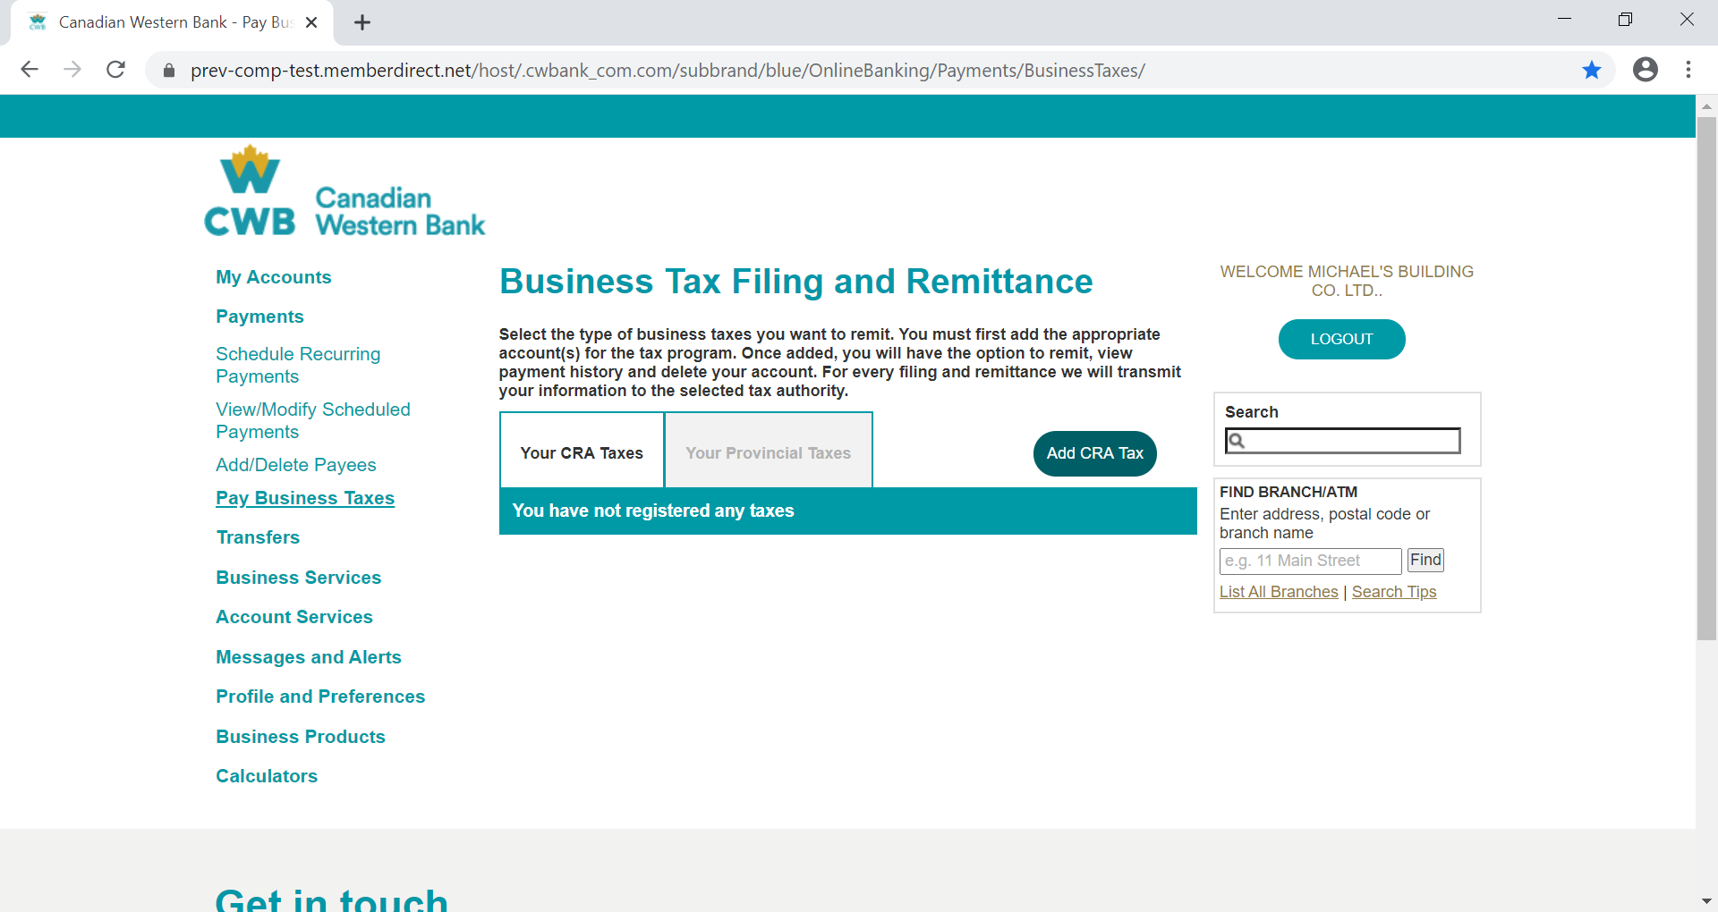

1. Click on **Add CRA Tax** to add a tax payee in other to file, remit or file & remit) for a federal tax.

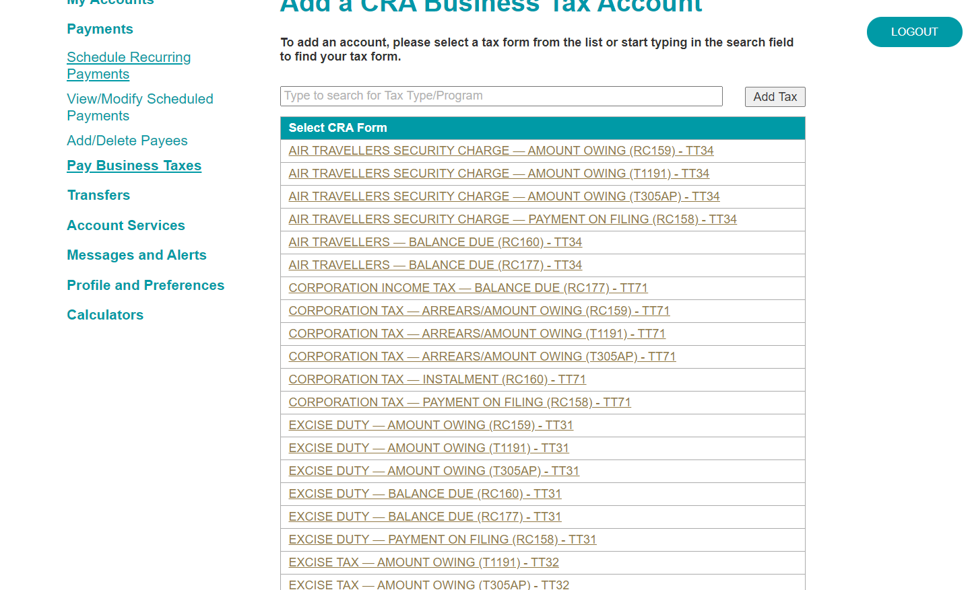

1. Select/Search for the applicable tax form from the pre-listed payees. There are over 80 tax forms which clients can choose from.

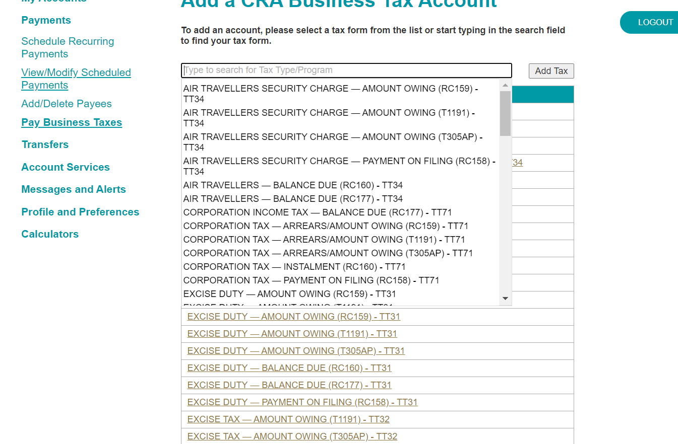

1. Enter the applicable business account number for the tax type selected and click on add business number. There is a validation that occurs here to check that the business account number entered corresponds to the tax form selected. Where there is a mismatch an error is flagged. Screen shot shows addtion of 2 different tax account type - GST and Corporate tax repectively

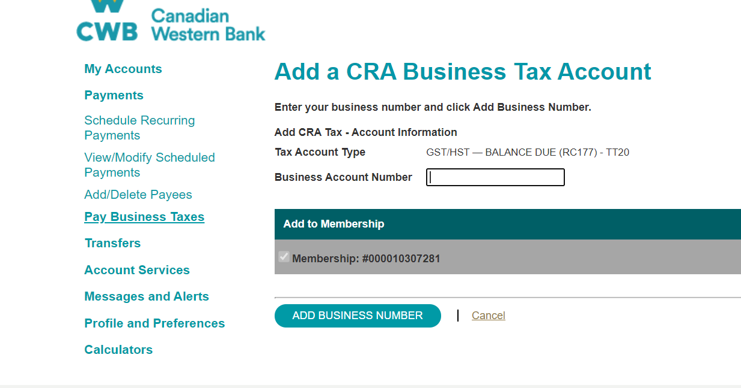

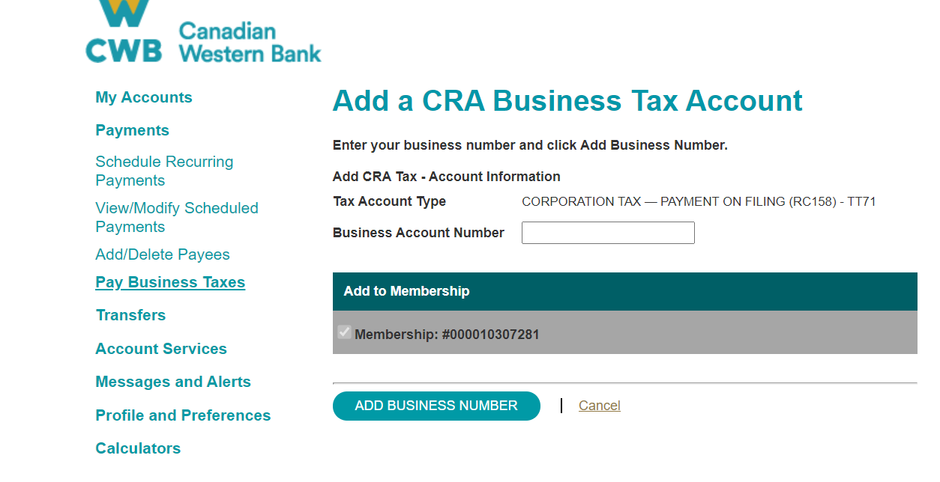

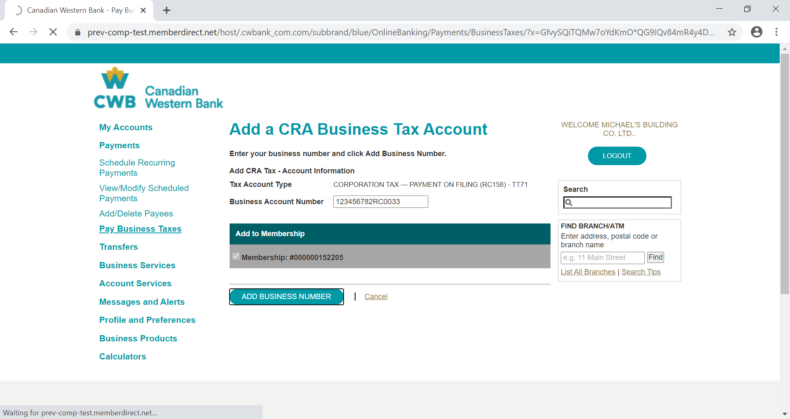

1. If the business account number entered corresponds to the tax form selected, the account is registered successfully.

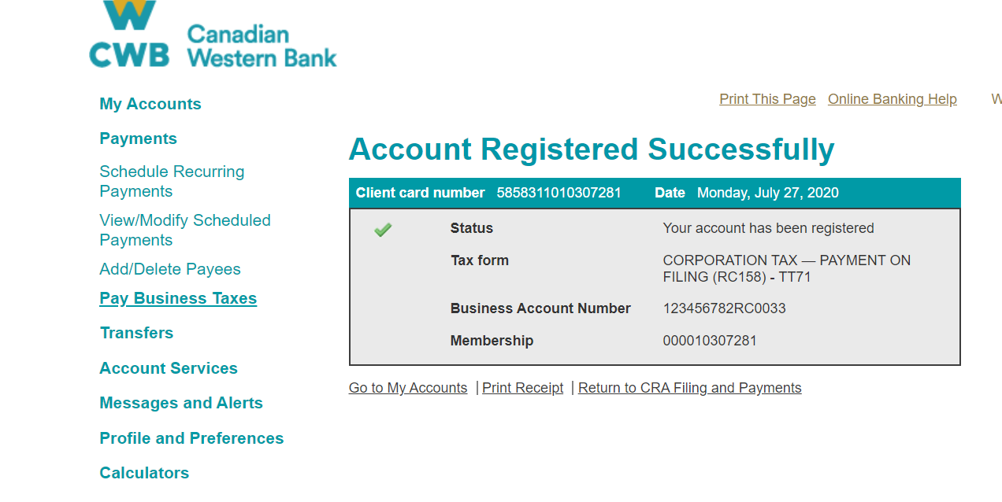

1. The registered account for each tax form becomes listed as tax payee for the client.

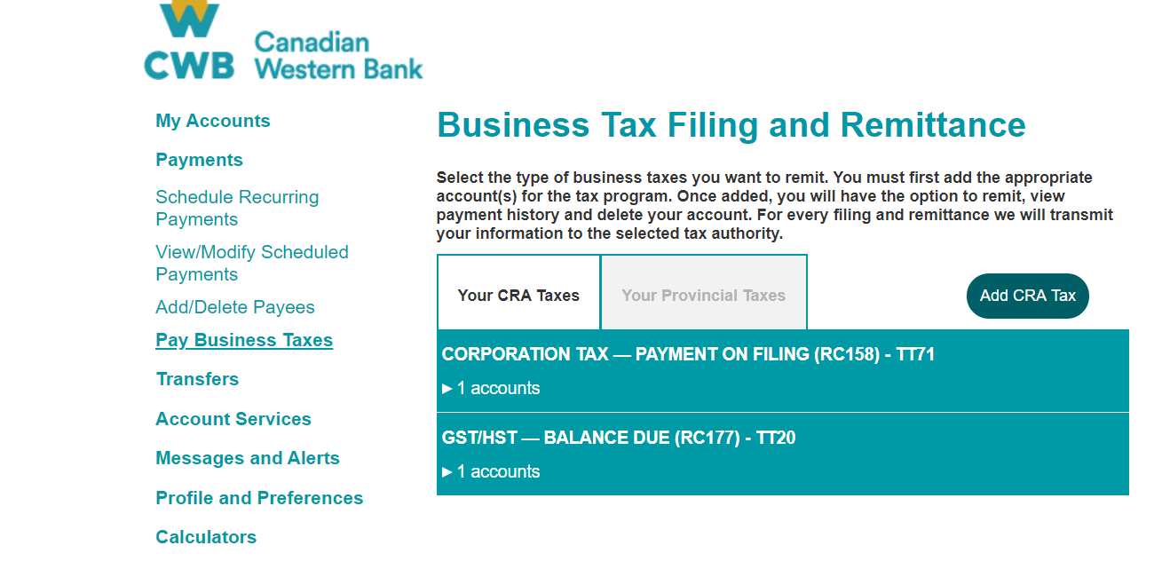

1. Ciick on the account to display the account number and actions that can be taken - **Remit, File , View History and Delete**

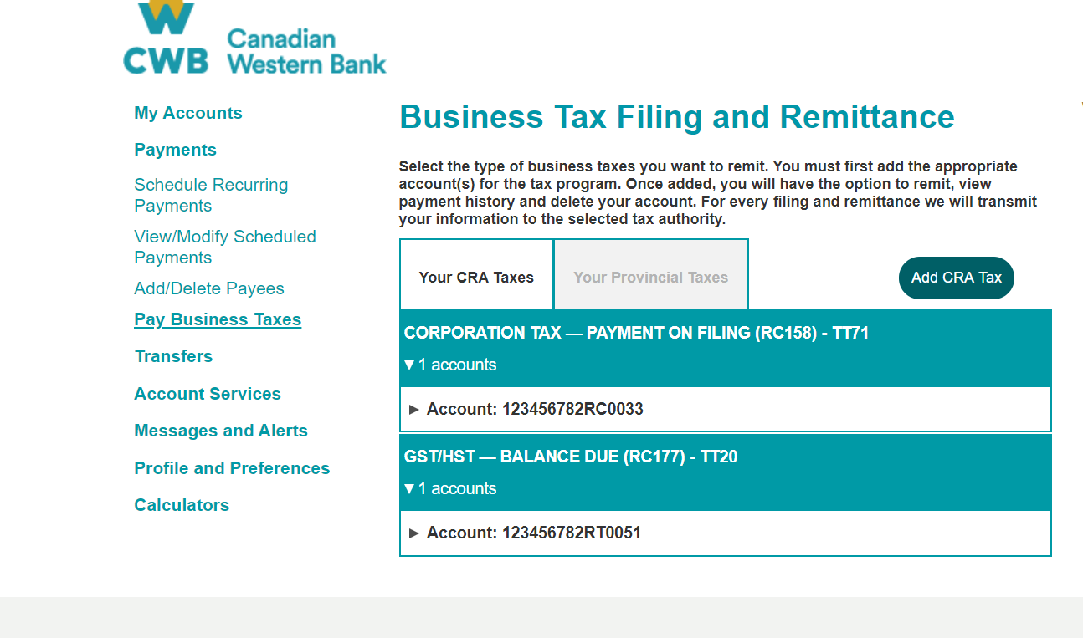

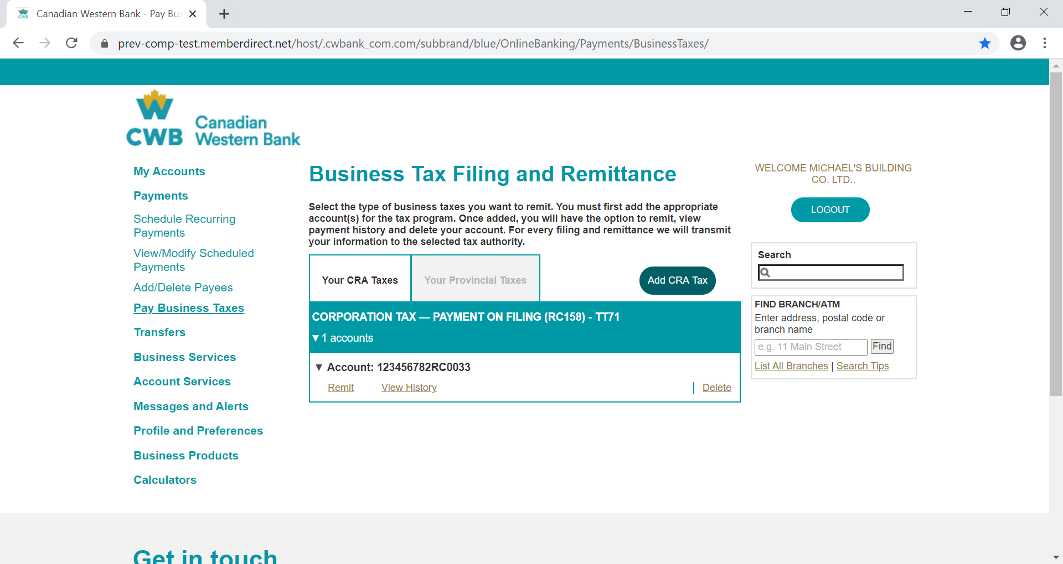

1. Click on **Remit** to make payment

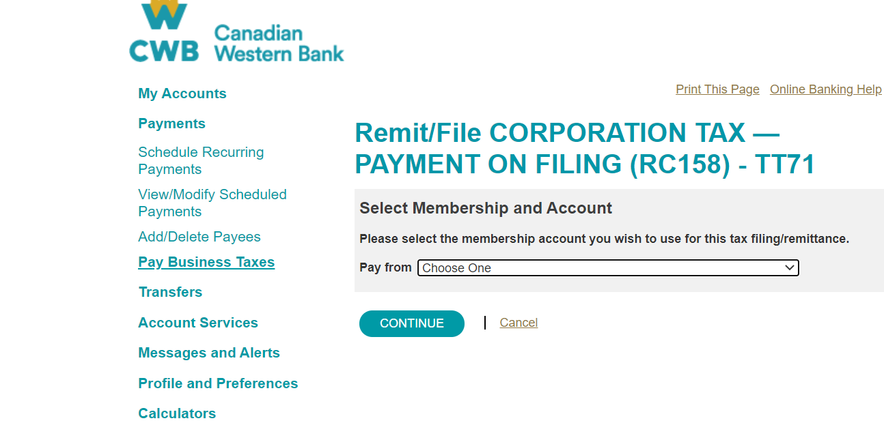

1. Select the account from which payment is to be made

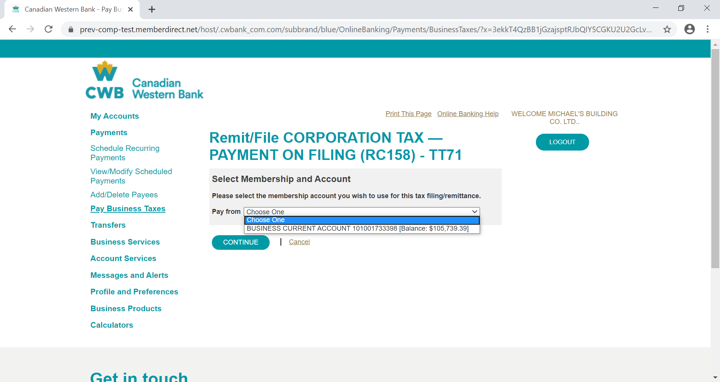

1. Enter the details for payment. The input data fields differs for different tax type/tax forms

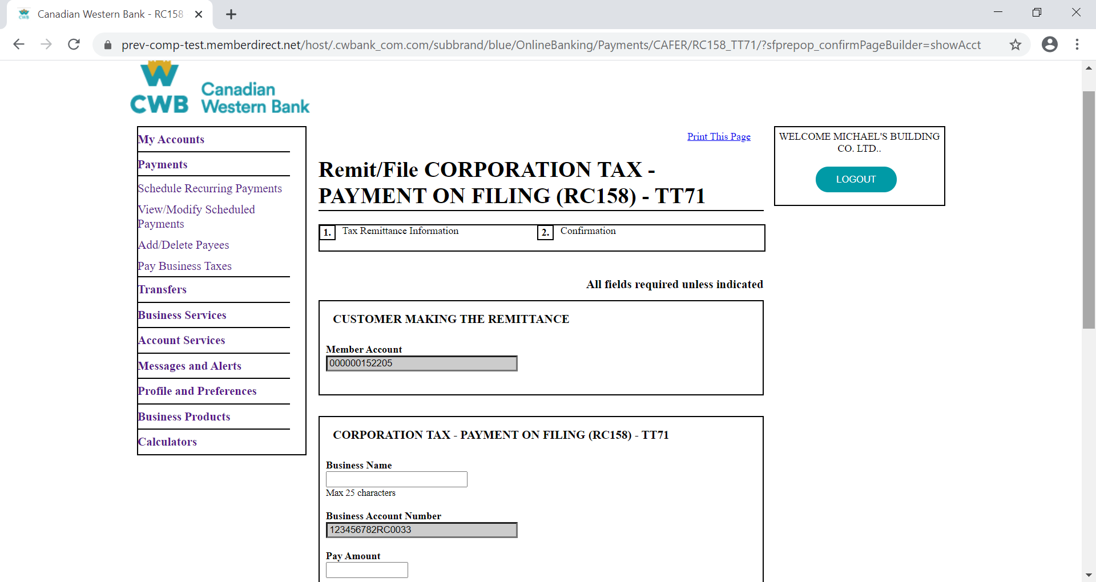

1. Payment can be scheduled within this page by selecting a payment date in the future

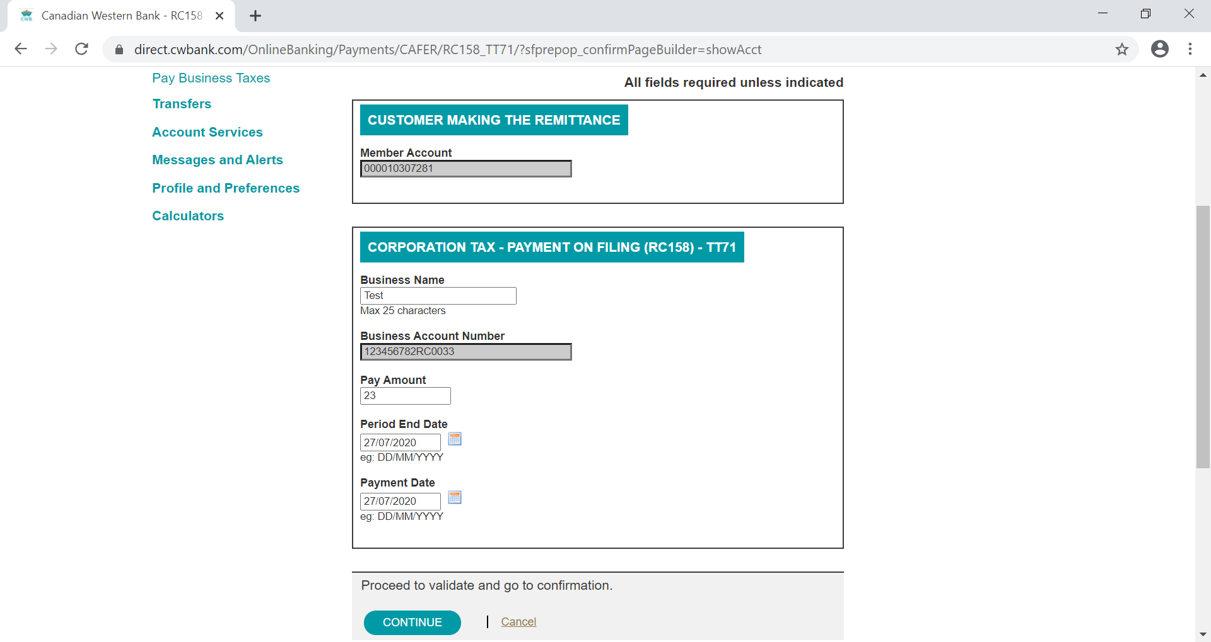

1. In some instances, a client is able to file tax before making remittance/payment. See sample below

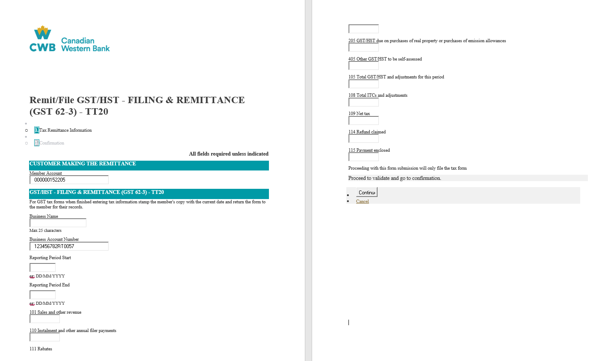

1. Confirmation page to check the information entered

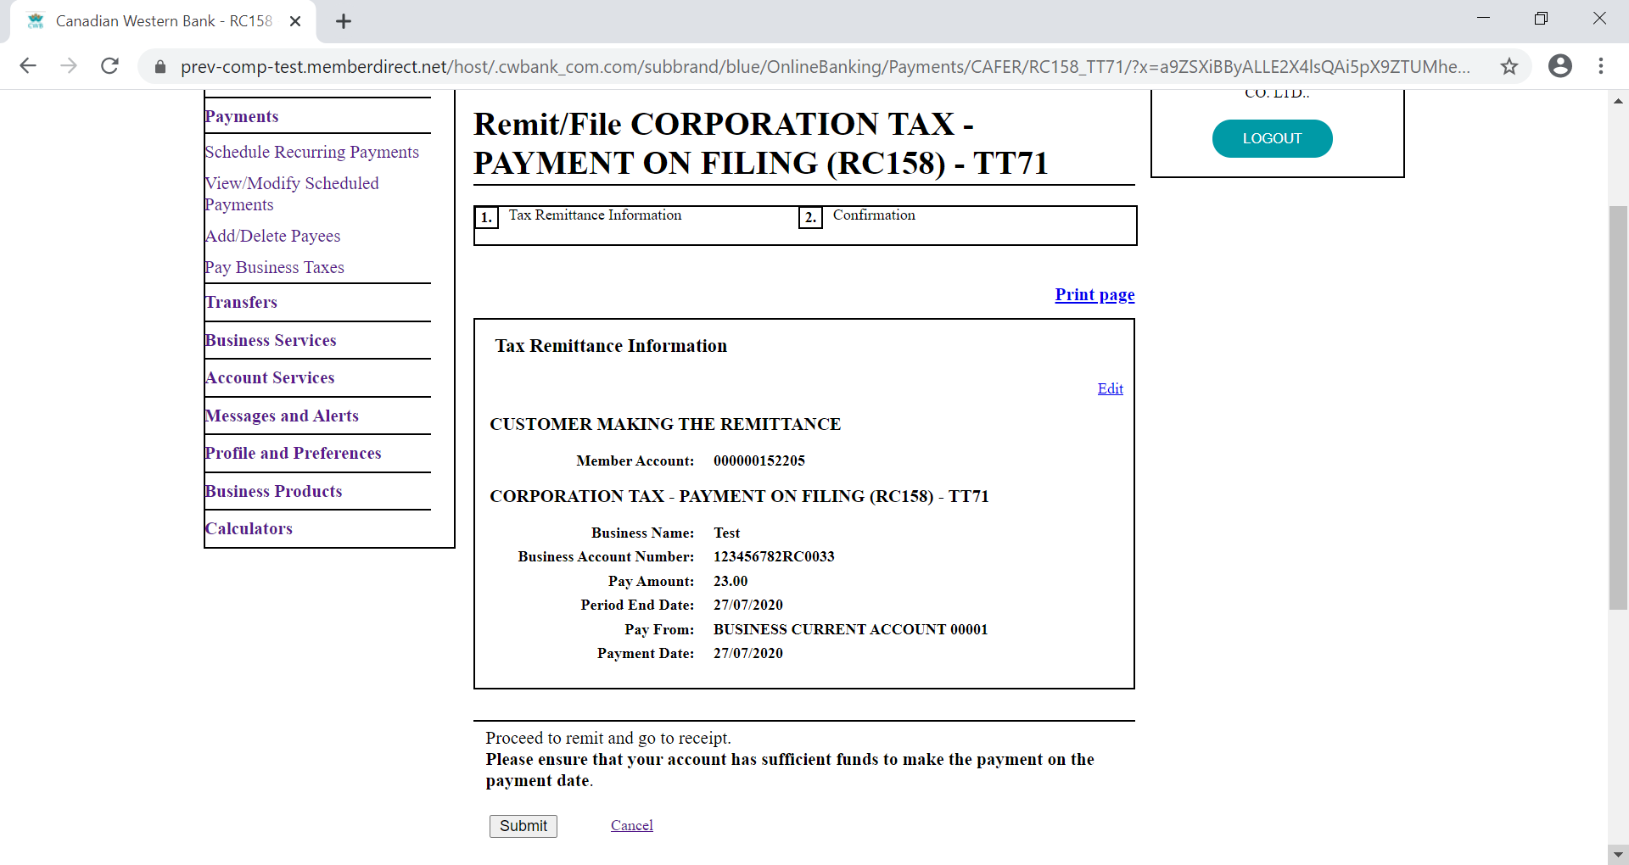

1. Upon confirmation and submision, remittance is made and the page is displayed to show successful remittance. Client account gets debited.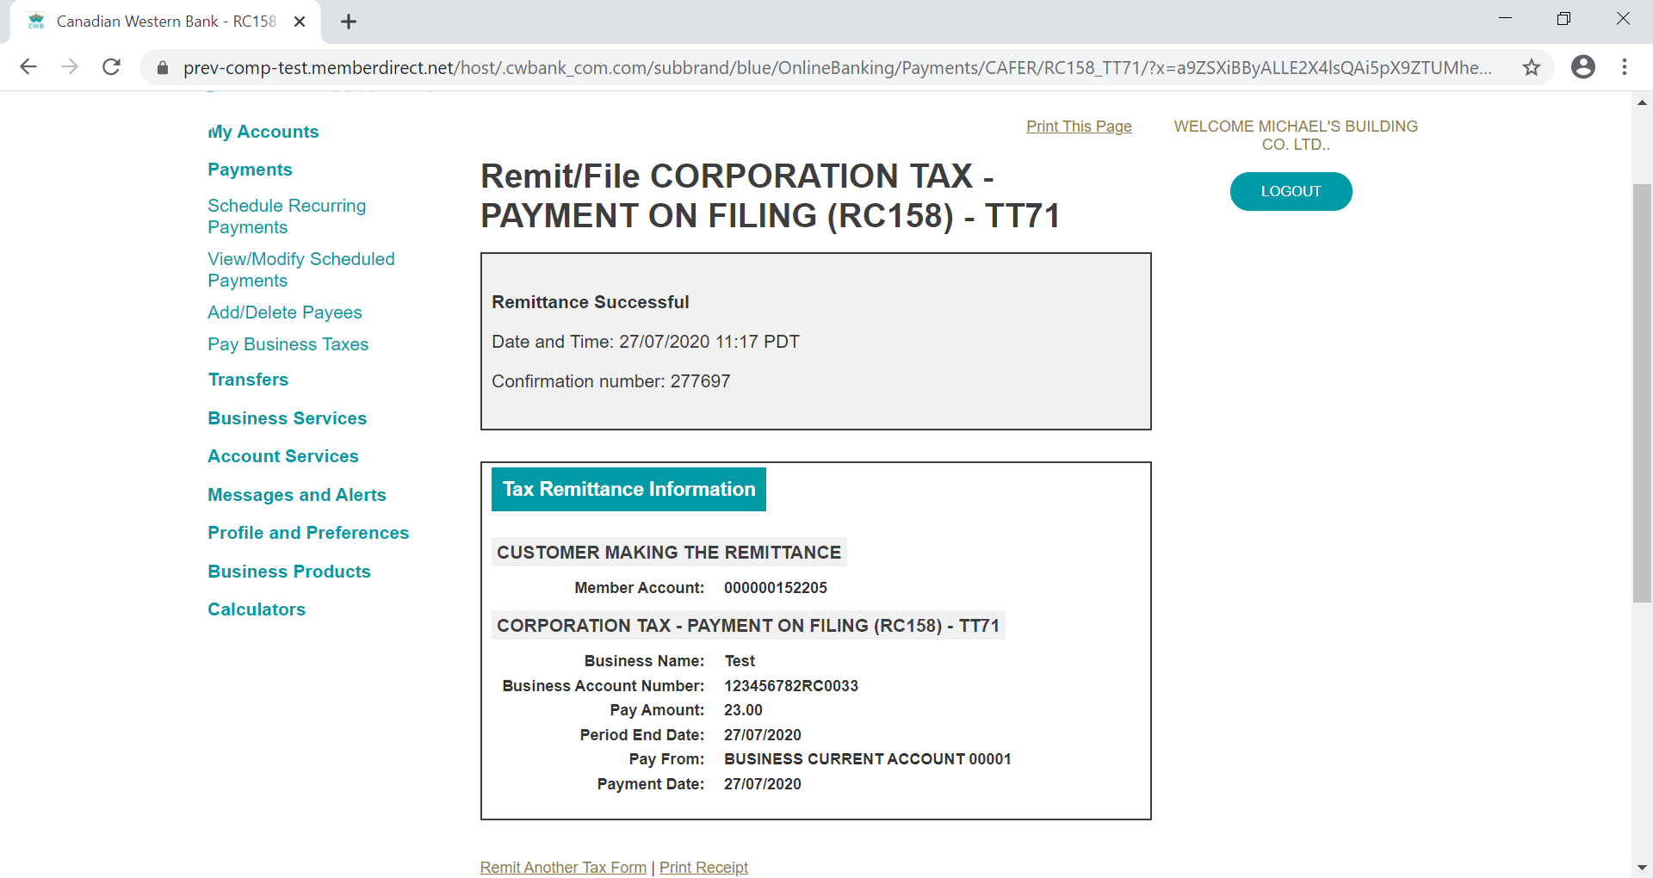
2. To view tax payment history for any tax type, click on **View History**



1. Enter the date range

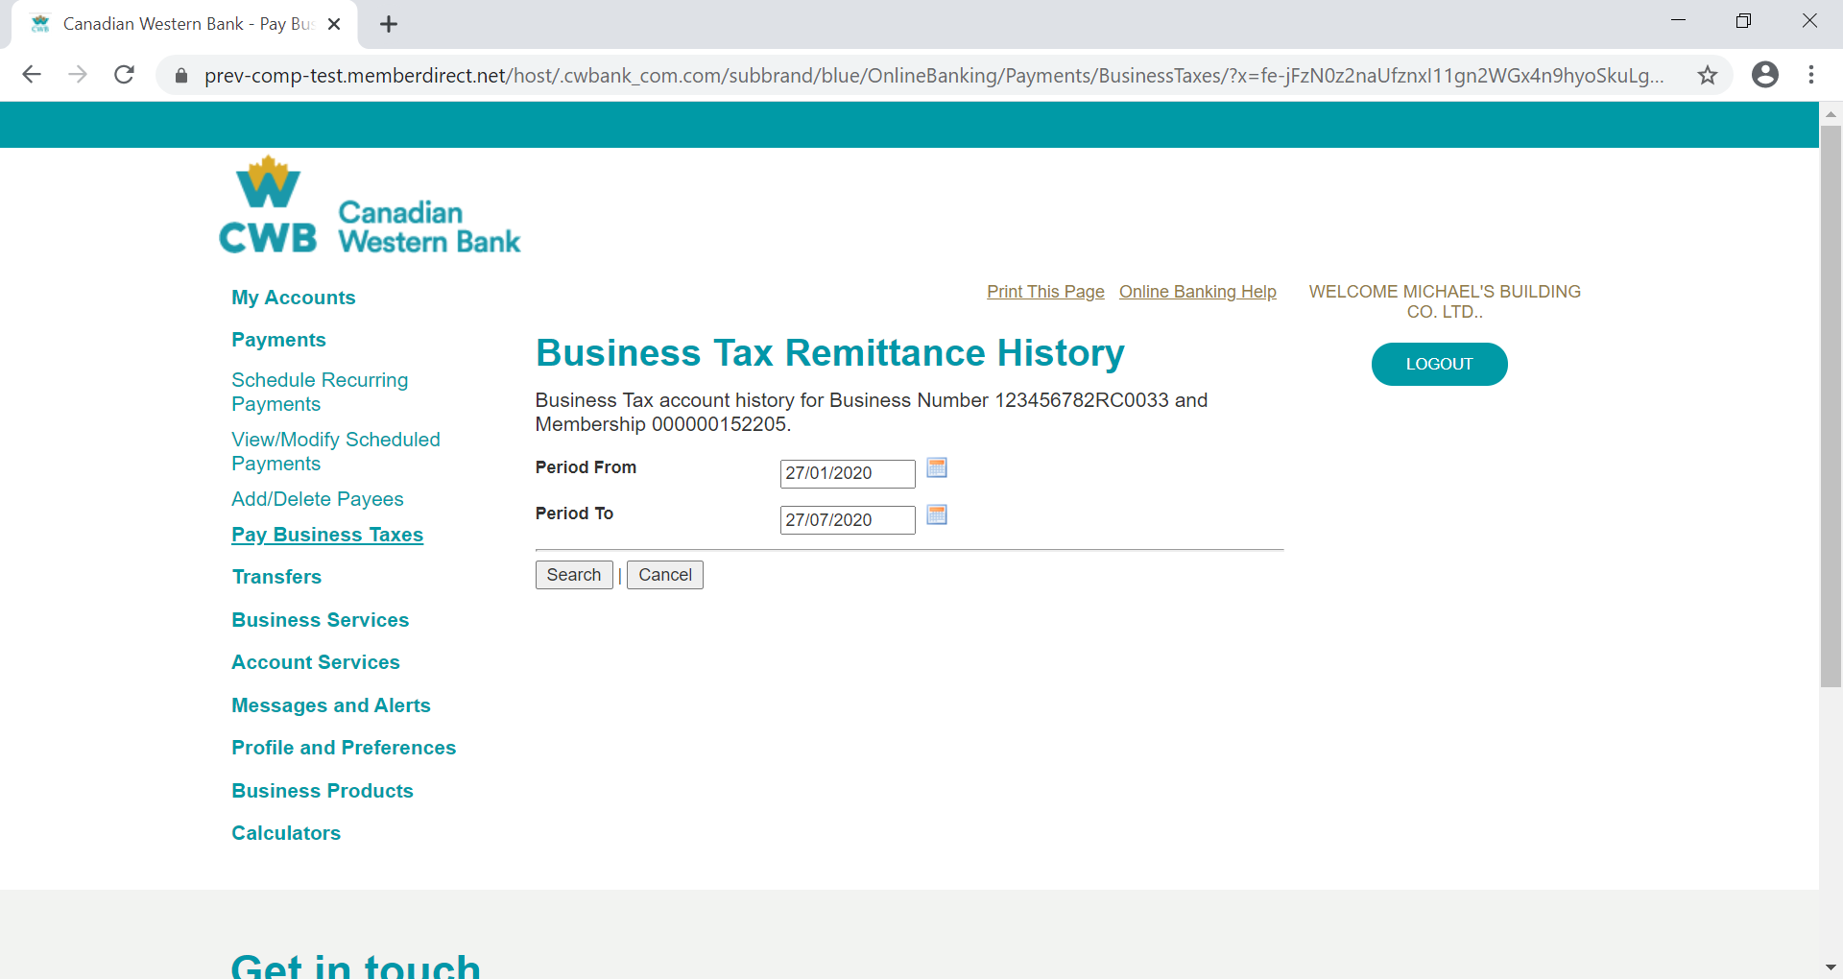

1. Payment/ Remittance history for the period entered is displayed

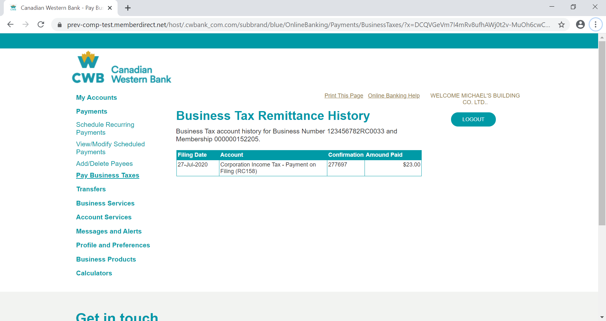

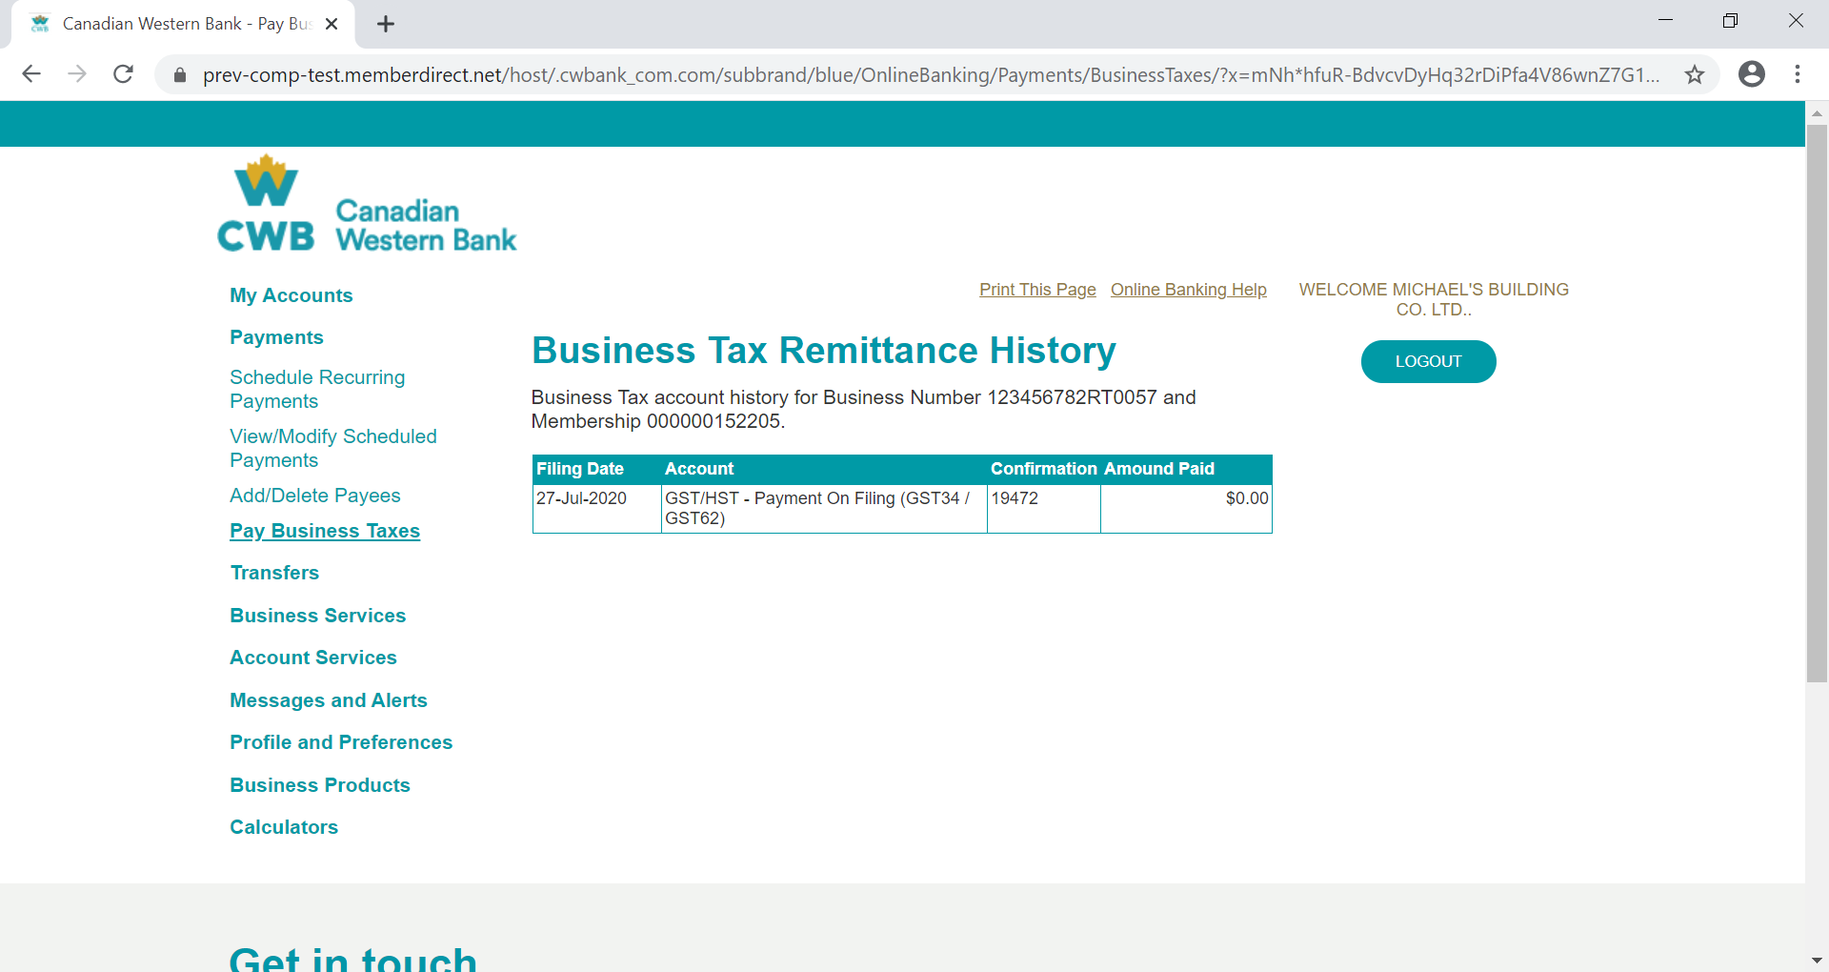

1. To delete business tax account, click on **delete**



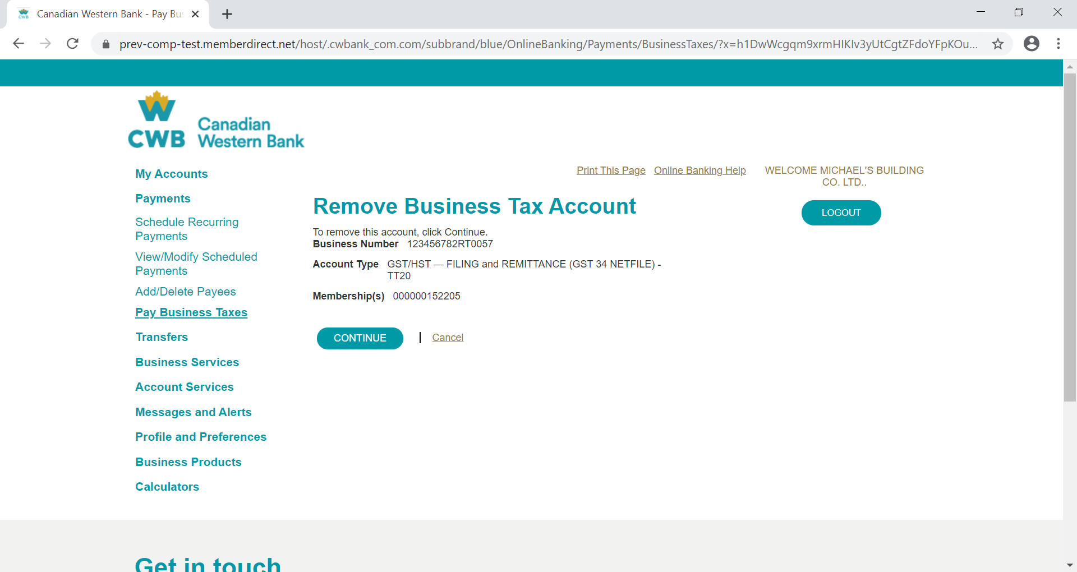

1. Tax account removed

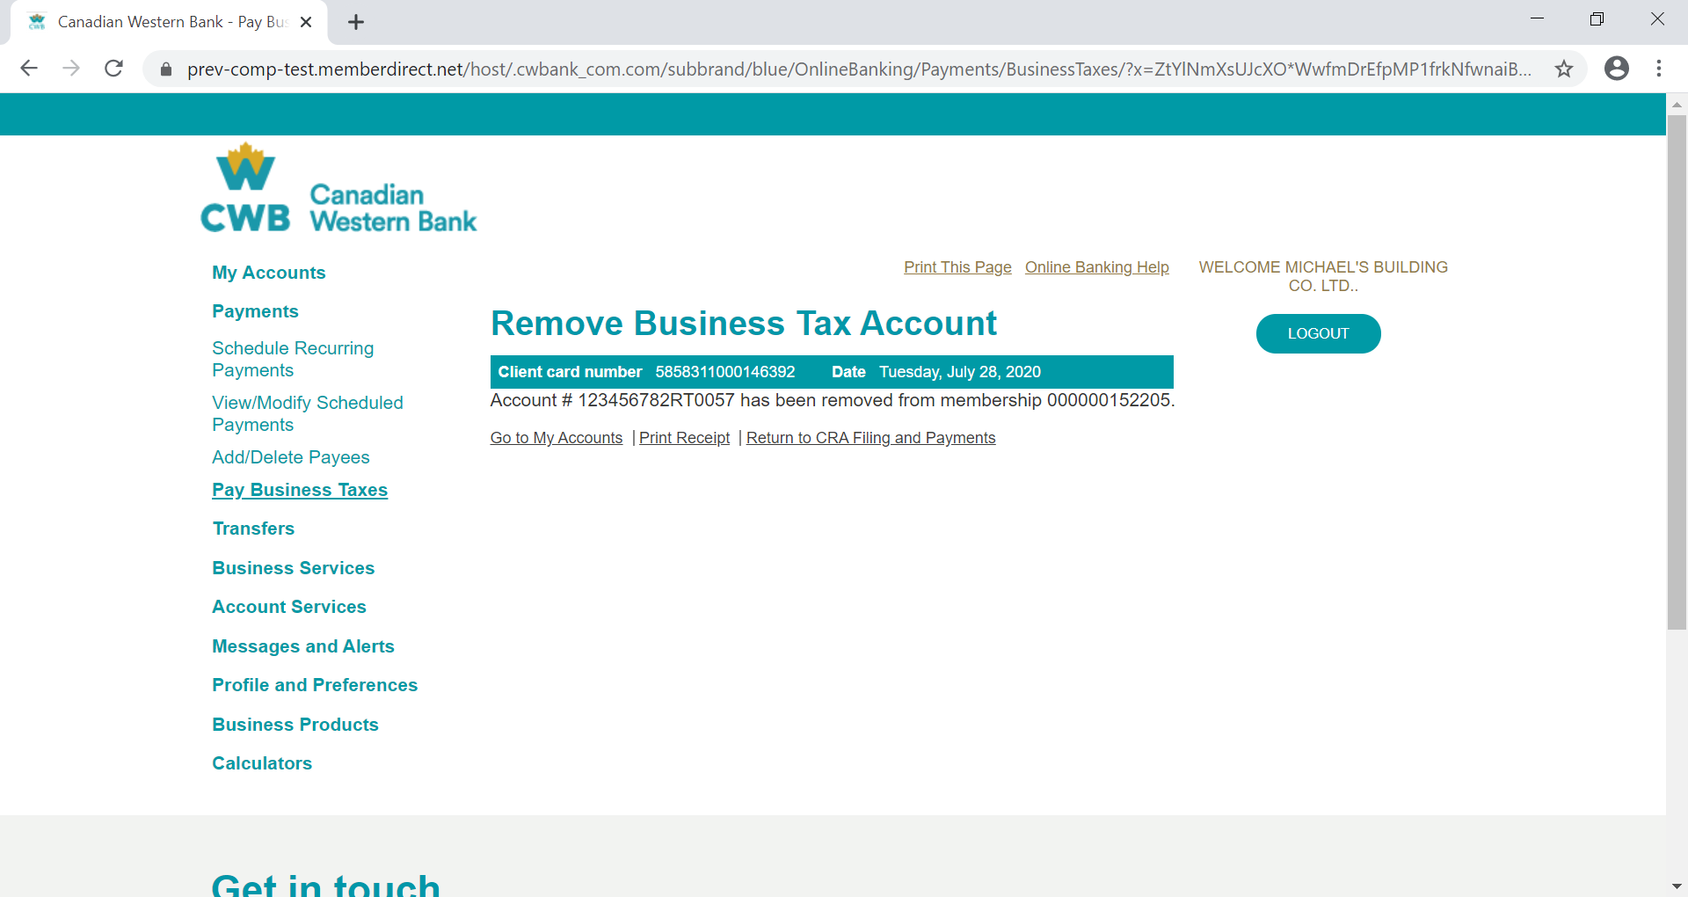

**Provincial Taxes**

1. Select the Pay Business Tax menu. Click on **Your Provincial Taxes** to process a provincial tax payment and click **Add Provincial Tax** to add a tax payee in other to file, remit or file & remit). Where the tax payee has previously been added, proceed to step 5

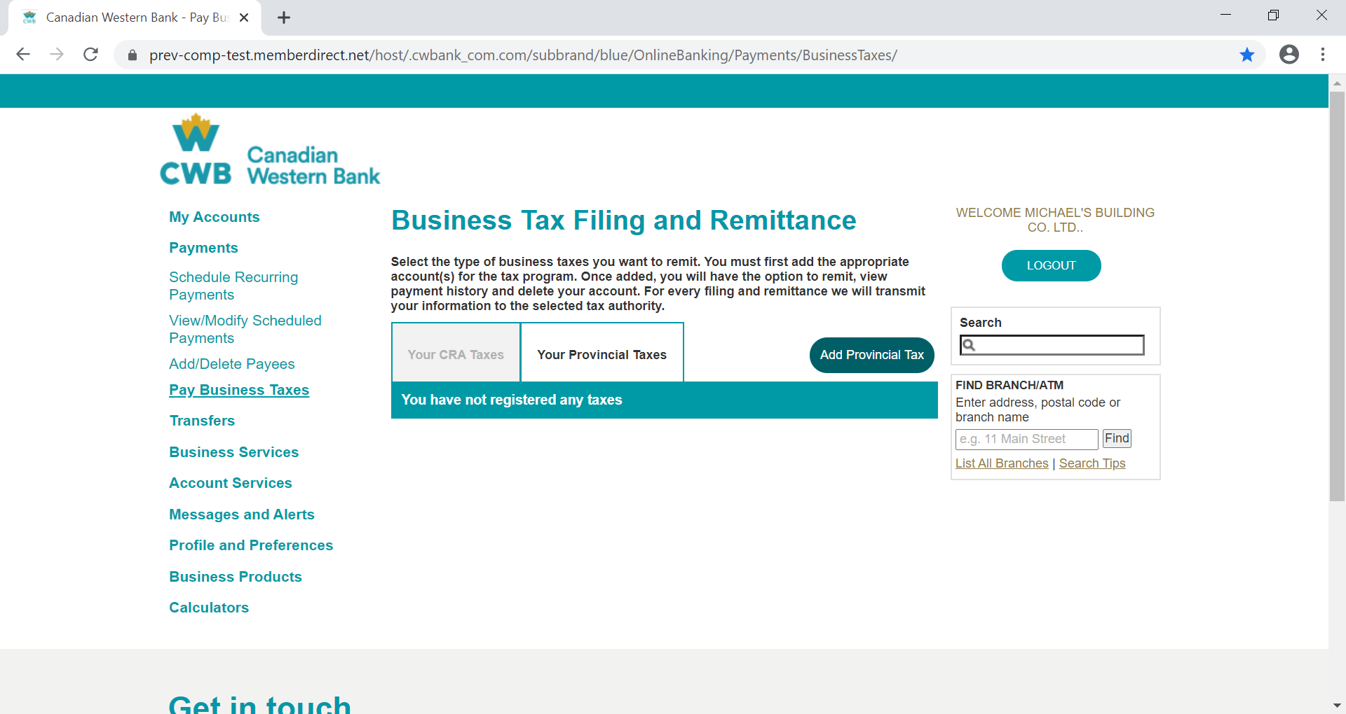

1. Select/Search for the applicable tax form from the pre-listed payees.

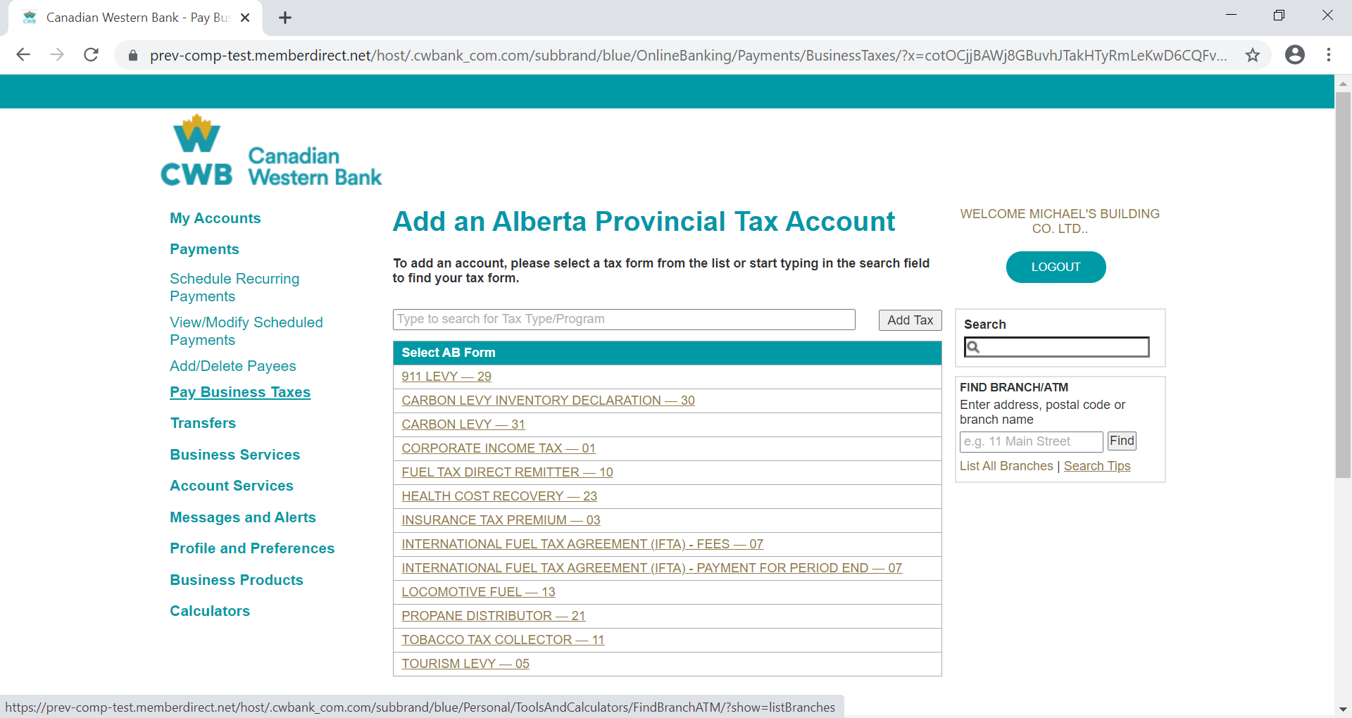

1. Enter the information required based on the tax form selected

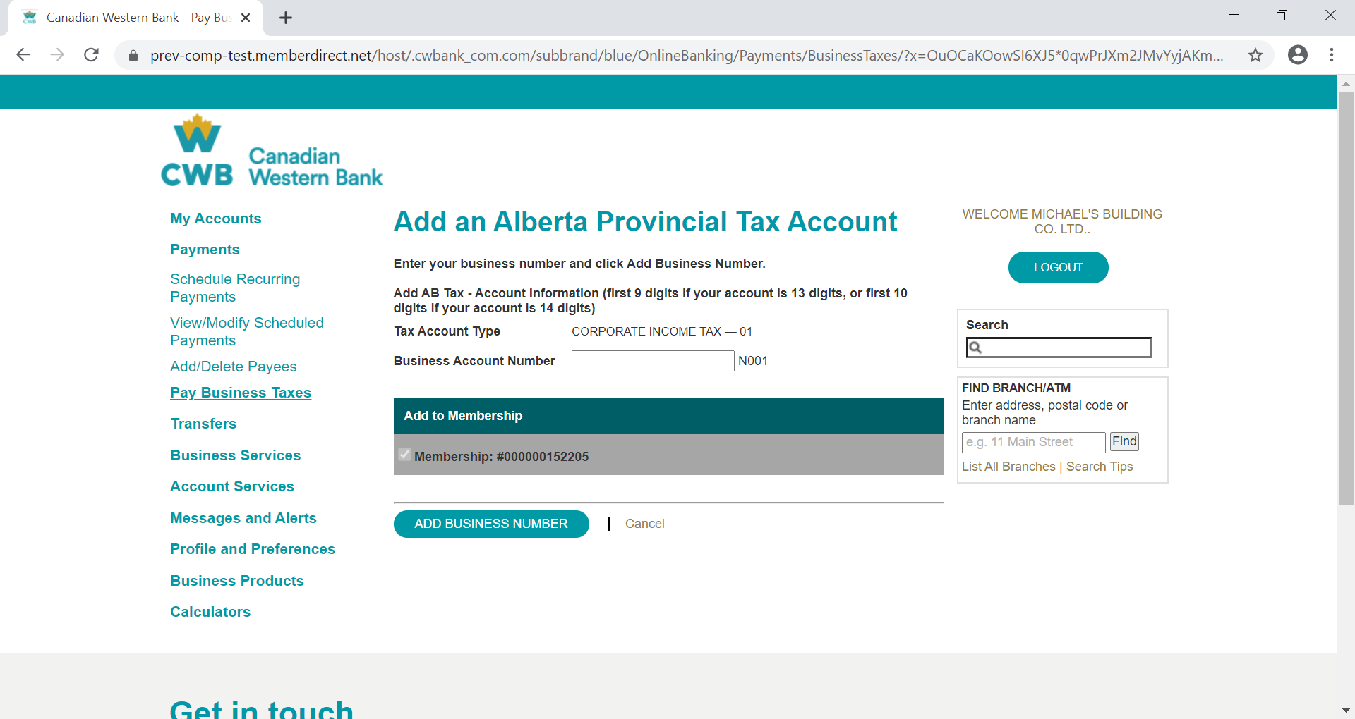

1. The system does a validation of the business account number entered by the client for the tax type selected. Where there is a mismatch an error is flagged, if correct account is registered successfully

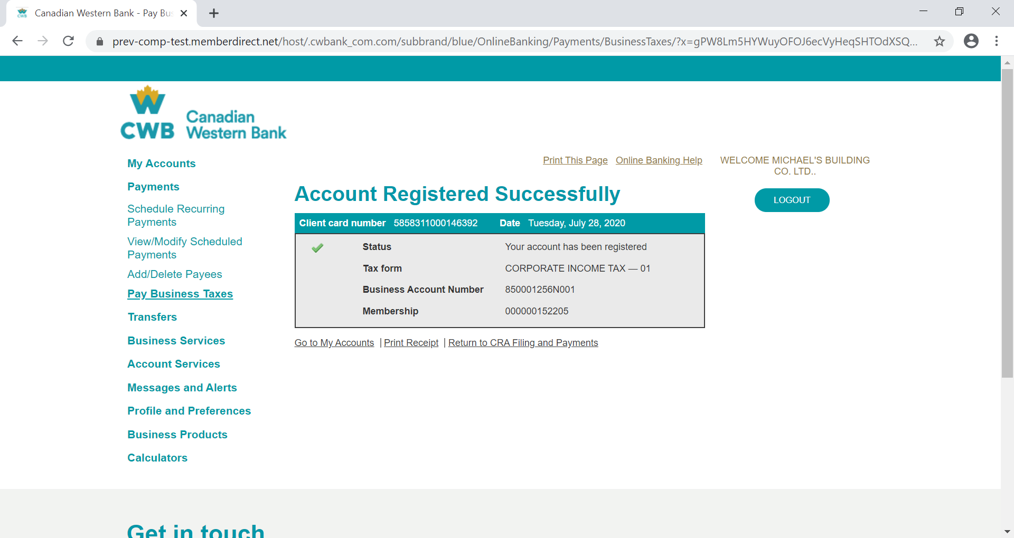

1. The registered account(s) are then listed as Tax payee for the client to be used for remittance and filing

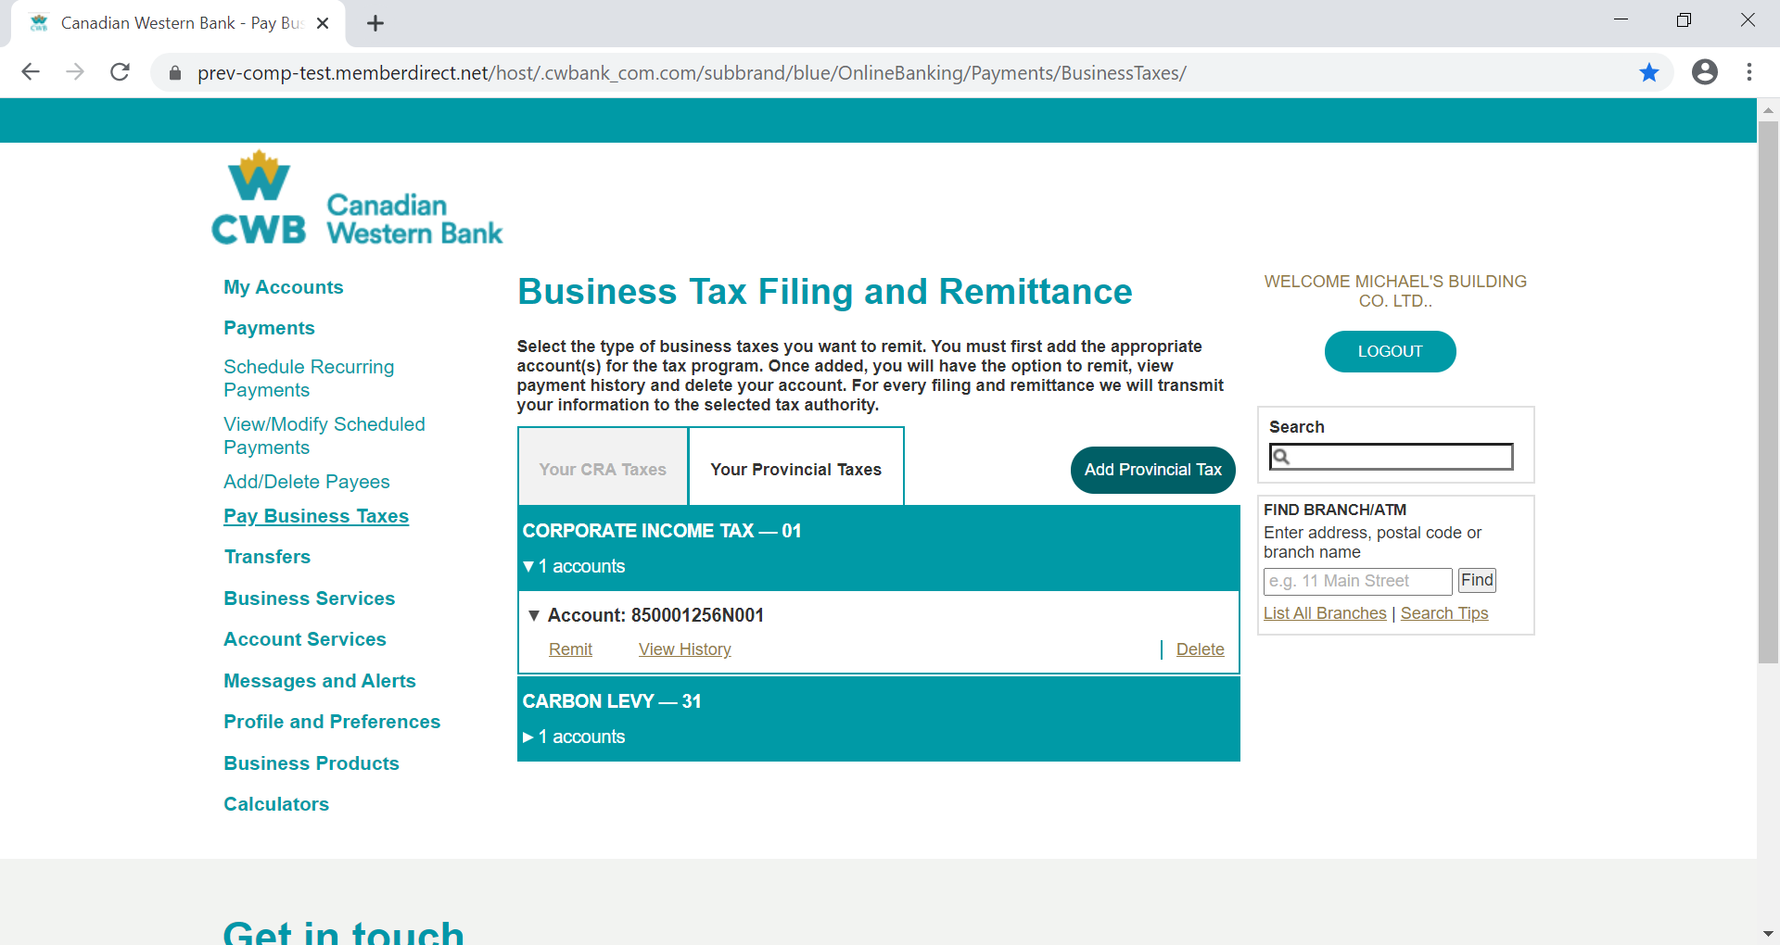

1. The process to remit, view history and delete Provincial taxes follows the same steps as outlined in the CRA TAX process above (steps 7 – 19).